**PROJECT REPORT**

*On the topic*

**‘CRIME DATA ANALYSIS FROM THE YEAR 2020 TO PRESENT’**

1. **Project Overview:**

This Project analyses the Crime data from 2020 to present using the tools Microsoft Excel and Microsoft Power BI for better understanding and analysis of the crime rates happened in various places of Los Angeles City.

1. **Tools Used:**

* Microsoft Excel: Spreadsheet Application used for organizing, analyzing, and visualizing data. It allows user to perform calculations, create charts, manage large datasheets and automate tasks using formulas and macros
* Microsoft Power BI: Tool from Microsoft used to analyse, visualize, and share data. It helps turn raw data into easy to understand charts, graphs and dashboards for better decision making.

1. **Datase**t:

* Source: Internet
* The dataset contains informations such as crime description, Date occurred, date reported, time occurred, Area Name, Weapon used for crime, Location , Latitude and longitude.

1. **Steps Followed**

* The raw data is first cleaned and reduced into minimum number of rows and columns for deriving meaningful insights from it. Removed blanks, formatted columns, removed duplicates, Filtered and sorted rows.
* Used excel formulas and Pivot table for basic Analysis.
* Imported the cleaned data into power BI. Data-> Get Data->From excel workbook or csv
* Built dashboards using charts , slicers, and KPI ‘s

1. **Key Insights**

* The crime data analysis over the years from 2020 to 2025 shows a decrease in the crime rate
* The most reported crime type reported across various places in Los Angeles is

Vehicle theft

* The peak time of crime happens is at 12pm

1. **Screenshots**

* Dashboard using Power BI

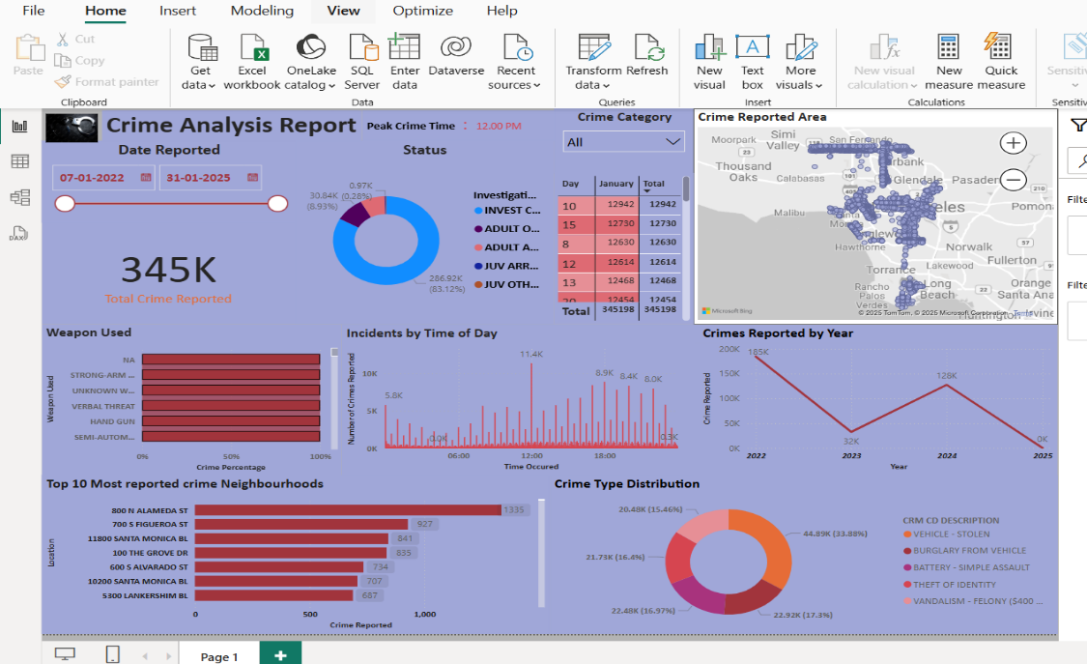

1. **Files Included**

* **‘**crime dataset. xlsx’ – Cleaned data and basic analysis
* ‘Crime Analysis Report .pbix’ – Power BI dashboard
* README.md’ – Project description

1. **How to Use**

Open ` crime dataset. xlsx’ ` to view the cleaned data.

Open `.‘Crime Analysis Report pbix` in Power BI Desktop to explore the visuals.